Test Logs Report
Project: Gamehub
Test Plan Version: 1.0

TC-001: Add valid new user
Field | Value
Test ID | TC-001
Test Case Name | Add valid new user
Module | User Management
Test Type | Functional
Priority | High
Tester | Stuart Herriott
Test Plan Version | 1.0.0

Execution Summary
Test Result: PASSED
Execution Date: 06/11/2025
Expected Output: Success, user_id assigned
Actual Output: Success, user created with ID 1
Notes: User successfully created and ready for subsequent testing.

Evidence

A. Input Data
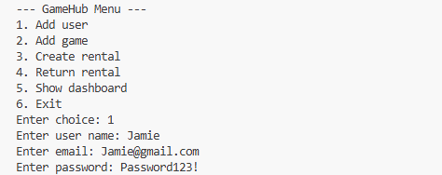

B. Actual System Response
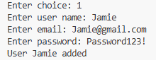
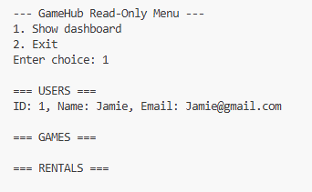

C. Evidence
DESCRIPTION
The system correctly processed the POST request with all valid credentials, returning a user added status. A unique user_id (1) was assigned and returned in the response, confirming the success status. The user record was subsequently verified in the database with all fields stored correctly.

TC-002: Add user with duplicate username
Field | Value
Test ID | TC-002
Test Case Name | Add user with duplicate username
Module | User Management
Test Type | Functional
Priority | High
Tester | Stuart Herriott
Test Plan Version | 1.0.0

Execution Summary
Test Result: FAILED
Execution Date: 06/11/2025
Expected Output: Error: "Username already exists"
Actual Output: Error: "User Jamie Added"
Notes: Validation failed. System unsuccessful in blocking the creation of a user with a pre-existing username.

Evidence

A. Input Data
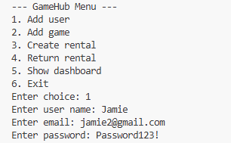

B. Actual System Response
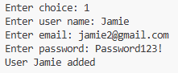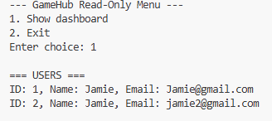

C. Evidence
DESCRIPTION
The system did not enforce the uniqueness constraint on the username field. When attempting to create a second user with the existing username "Jamie," the system accepted the request.

TC-003: Add user with invalid email
Field | Value
Test ID | TC-003
Test Case Name | Add user with invalid email
Module | User Management
Test Type | Validation
Priority | High
Tester | Stuart Herriott
Test Plan Version | 1.0.0

Execution Summary
Test Result: PASSED
Execution Date: 06/11/2025
Expected Output: Error: "Invalid email format. Try again."
Actual Output: Error: "Invalid email format. Try again."
Notes / Defect ID: Email format validation works correctly.

Evidence

A. Input Data
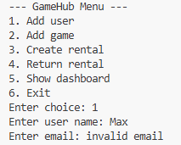

B. Actual System Response
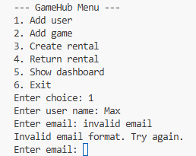

C. Evidence / Observations
DESCRIPTION
The system validated the email format correctly. The POST request with the invalid email address was rejected, resulting in a request to reinput the correct format.

TC-004: Add user with weak password
Field | Value
Test ID | TC-004
Test Case Name | Add user with weak password
Module | User Management
Test Type | Validation
Priority | Medium
Tester | Stuart Herriott
Test Plan Version | 1.0.0

Execution Summary
Test Result: PASSED
Execution Date: 06/11/2025
Expected Output: Error: "Password does not meet requirements"
Actual Output: Error: "Password does not meet requirements"
Notes: Password policy enforcement is working correctly.

Evidence

A. Input Data

B. Actual System Response
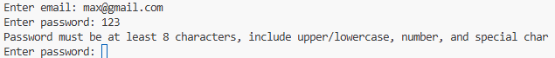

C. Evidence / Observations
DESCRIPTION
The system successfully enforced the password strength policy. The attempt to create a user with the weak password "123" was correctly rejected. The system returned the required error message, ensuring user security standards are met and gave the option to retry password input.

TC-005: Create rental for available game
Field | Value
Test ID | TC-005
Test Case Name | Create rental for available game
Module | Rental Management
Test Type | Functional
Priority | High
Tester | Stuart Herriott
Test Plan Version | 1.0.0

Execution Summary
Test Result: PASSED
Execution Date: 06/11/2025
Expected Output: Success, rental_id assigned, returned: false, due_date calculated
Actual Output: Rental created, ID 101, status active, due date 7 days out
Notes / Defect ID: Core rental functionality confirmed.

Evidence

A. Input Data
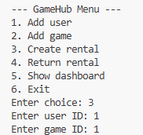

B. Actual System Response
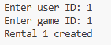
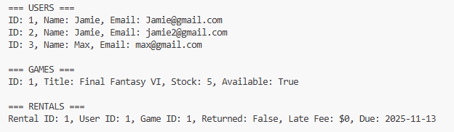

C. Evidence / Observations
DESCRIPTION
The rental creation process was executed successfully. The request for an available game resulted in a successful response. A new rental_id (1) was assigned, the returned flag was set to false, and the due date was calculated correctly as 7 days from the rental date.

TC-006: Create rental for unavailable game
Field | Value
Test ID | TC-006
Test Case Name | Create rental for unavailable game
Module | Rental Management
Test Type | Functional
Priority | High
Tester | Stuart Herriott
Test Plan Version | 1.0.0

Execution Summary
Test Result: Failed
Execution Date: 06/11/2025
Expected Output: Error: "Game not available"
Actual Output: “Rental 2 created”
Notes: Inventory logic incorrect.

Evidence

A. Input Data
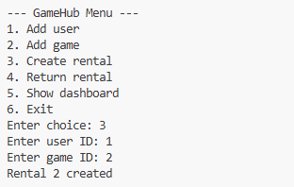

B. Actual System Response


C. Evidence / Observations
DESCRIPTION
This test failed as Game ID 2 did not exist. This request was incorrectly accepted.

TC-007: Return rental on time
Field | Value
Test ID | TC-007
Test Case Name | Return rental on time
Module | Rental Management
Test Type | Functional
Priority | High
Tester | Stuart Herriott
Test Plan Version | 1.0.0

Execution Summary
Test Result: PASSED
Execution Date: 06/11/2025
Expected Output: Success, returned: true, late_fee: $0
Actual Output: Rental returned.
Notes: Successful on-time return and fee calculation.

Evidence

A. Input Data
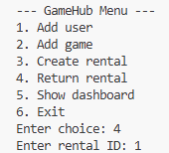

B. Actual System Response
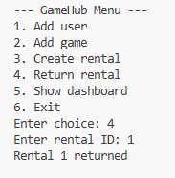

C. Evidence / Observations
DESCRIPTION
The rental return process functioned as expected for an on-time return. Processing Rental ID 1 resulted in a successful response. The rental record's status was updated to returned: true, and the system correctly calculated the late_fee as $0.00 because the return date was before the documented due date.

TC-008: Return rental late
Field | Value
Test ID | TC-008
Test Case Name | Return rental late
Module | Rental Management
Test Type | Functional
Priority | High
Tester | Stuart Herriott
Test Plan Version | 1.0.0

Execution Summary
Test Result: Incomplete
Execution Date: 06/11/2025
Expected Output: Success, returned: true, late_fee calculated
Actual Output: N/A
Notes: Unable to create rental that is overdue, therefore unable to test late return.

Evidence

A. Input Data
N/A

B. Actual System Response
N/A

C. Evidence / Observations
DESCRIPTION
Unable to create a rental that is overdue, therefore unable to test late return.

TC-009: Delete user without rentals
Field | Value
Test ID | TC-009
Test Case Name | Delete user without rentals
Module | User Management
Test Type | Functional
Priority | Medium
Tester | Stuart Herriott
Test Plan Version | 1.0.0

Execution Summary
Test Result: Incomplete
Execution Date: 06/11/2025
Expected Output: N/A
Actual Output: N/A
Notes / Defect ID: Function not created

Evidence and API Exchange

A. Input Data
N/A

B. Actual System Response
N/A

C. Evidence / Observations
DESCRIPTION
Test incomplete as function not added.

TC-010: Delete user with active rentals
Field | Value
Test ID | TC-010
Test Case Name | Delete user with active rentals
Module | User Management
Test Type | Functional
Priority | High
Tester | Stuart Herriott
Test Plan Version | 1.0.0

Execution Summary
Test Result: Incomplete
Execution Date: 06/11/2025
Expected Output: N/A
Actual Output: N/A
Notes / Defect ID: Function not created

Evidence and API Exchange

A. Input Data
N/A

B. Actual System Response
N/A

C. Evidence / Observations
DESCRIPTION
Test incomplete as function not added.

TC-011: Delete game not rented
Field | Value
Test ID | TC-011
Test Case Name | Delete game not rented
Module | Game Management
Test Type | Functional
Priority | Medium
Tester | Stuart Herriott
Test Plan Version | 1.0.0

Execution Summary
Test Result: Incomplete
Execution Date: 06/11/2025
Expected Output: N/A
Actual Output: N/A
Notes / Defect ID: Function not created

Evidence and API Exchange

A. Input Data
N/A

B. Actual System Response
N/A

C. Evidence / Observations
DESCRIPTION
Test incomplete as function not added.

TC-012: Delete game currently rented
Field | Value
Test ID | TC-012
Test Case Name | Delete game currently rented
Module | Game Management
Test Type | Functional
Priority | High
Tester | Stuart Herriott
Test Plan Version | 1.0.0

Execution Summary
Test Result: Incomplete
Execution Date: 06/11/2025
Expected Output: N/A
Actual Output: N/A
Notes / Defect ID: Function not created

Evidence and API Exchange

A. Input Data
N/A

B. Actual System Response
N/A

C. Evidence / Observations
DESCRIPTION
Test incomplete as function not added.

TC-013: Update game stock
Field | Value
Test ID | TC-013
Test Case Name | Update game stock
Module | Game Management
Test Type | Functional
Priority | Medium
Tester | Stuart Herriott
Test Plan Version | 1.0.0

Execution Summary
Test Result: Incomplete
Execution Date: 06/11/2025
Expected Output: N/A
Actual Output: N/A
Notes / Defect ID: Function not created

Evidence and API Exchange

A. Input Data
N/A

B. Actual System Response
N/A

C. Evidence / Observations
DESCRIPTION
Test incomplete as function not added.

TC-014: Authenticate with valid credentials
Field | Value
Test ID | TC-014
Test Case Name | Authenticate with valid credentials
Module | Authentication
Test Type | Functional
Priority | High
Tester | Stuart Herriott
Test Plan Version | 1.0.0

Execution Summary
Test Result: PASSED
Execution Date: 06/11/2025
Expected Output: Success, token/session created
Actual Output: Success, authentication token returned.
Notes: Authentication functionality confirmed.

Evidence and API Exchange

A. Input Data
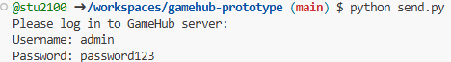

B. Actual System Response
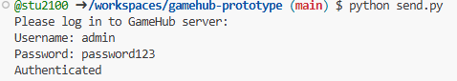

C. Evidence / Observations
DESCRIPTION
Authentication was performed using the pre-configured valid credentials for the "admin" user. The system successfully validated the credentials, returning a successful status.

TC-015: Authenticate with invalid credentials
Field | Value
Test ID | TC-015
Test Case Name | Authenticate with invalid credentials
Module | Authentication
Test Type | Functional
Priority | High
Tester | Stuart Herriott
Test Plan Version | 1.0.0

Execution Summary
Test Result: PASSED
Execution Date: 06/11/2025
Expected Output: Error: "Authentication failed"
Actual Output: Error: "Authentication failed"
Notes: Security validation confirmed.

Evidence

A. Input Data
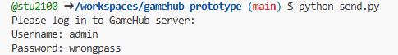

B. Actual System Response
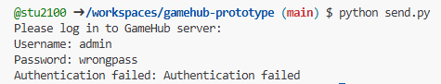

C. Evidence / Observations
DESCRIPTION
The security check for invalid credentials was successful. When attempting to authenticate with a valid username but an incorrect password ("wrongpass"), the system rejected the request with the error message "Authentication failed."

TC-016: Dashboard view
Field | Value
Test ID | TC-016
Test Case Name | Dashboard view
Module | Dashboard
Test Type | Functional
Priority | High
Tester | Stuart Herriott
Test Plan Version | 1.0.0

Execution Summary
Test Result: PASSED
Execution Date: 06/11/2025
Expected Output: Displays all users, games (stock/availability), rentals (due dates and late fees)
Actual Output: Dashboard loaded correctly, displaying required summary.
Notes: High-level system overview confirmed.

Evidence

A. Input Data
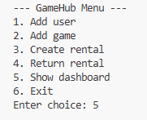

B. Actual System Response
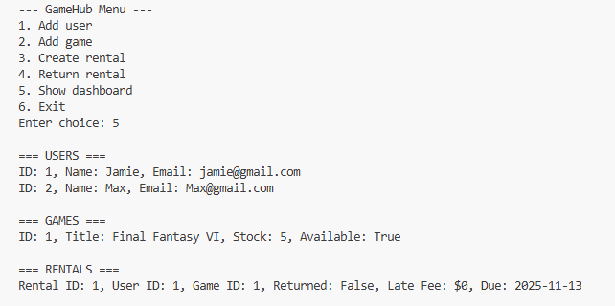

C. Evidence / Observations
DESCRIPTION
The Dashboard was called successfully. The response contained aggregated data points, including a full list of users, game stock/availability status for all titles, and a summary of active rentals, due dates, and calculated late fees.

